Welcome to Pošumaví

Pošumavi region stretches south from Pilsen towards the Šumava mountains. Rich in history, this region combines the attractive natural scenery, sparsely populated picturesque countryside and historically valuable sites and monuments. Thebeauty and uniqueness of this undiscovered region is furthermore enhanced with a scent of remaining folk arts spirit.

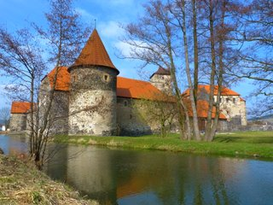

**Pošumavi region stretches south from Pilsen towards the Šumava mountains. Rich in history, this region combines the attractive natural scenery, sparsely populated picturesque countryside and historically valuable sites and monuments. Thebeauty and uniqueness of this undiscovered region is furthermore enhanced with a scent of remaining folk arts spirit.**

Charming villages and towns invite you to discover numerous folk buildings and small local museums. Consequently, you can breathe the fresh air from the meadows and woods. The entire Pošumaví is interwoven with series of marked hikingtrails and bike paths.

The whole area lies in a beautiful hilly countryside at the foothills of the Sumava. From tops of the hills or numerous viewing towers you may enjoy lovely views of the green Šumava panorama, or to look as far as the plains of South Bohemia.

Pošumaví is rich in cultural, social and sporting life. The summer months offer plenty of concerts, theatrical performances, local art shows and historical events. Of course, you must not forget to taste the local cuisine.